

2015 Media Team Report

Executive summary

The key activities of the Media Team during 2015 were managing and curating the organisation's social media presence. The highlights of the year were;

- The @linuxaustralia Twitter account increased followers from just over 900 at December 2014 to 1257 at 20 December 2015 through broadcasting and amplifying relevant content pieces
- The handling of security breaches garnered positive sentiment, with several interactions indicating that these breaches were dealt with positively and professionally

The team is faced with the following challenges in future years;

- There is a lack of available volunteer effort (also faced by other teams) to undertake production of a member-focussed newsletter or similar communication piece.
Recommendation: That Council 2016 consider a programme of volunteer recruitment
- We lack the platforms to be able to undertake targeted or niche communications to members of the LA community. A stronger Membership management system is required.
Recommendation: That MemberDB be replaced as a priority

Social media channels

The use of Twitter as a key communications channel has continued to grow, from 620 followers at the end of 2013 to over 910 at end 2014 to 1257 as at 20 December 2015. Scheduling tools are used to schedule important announcements ahead of time, and current relevant articles are Tweeted as appropriate. Other related accounts, such as @linuxconfau – often amplify broadcasts made on the @linuxaustralia account.

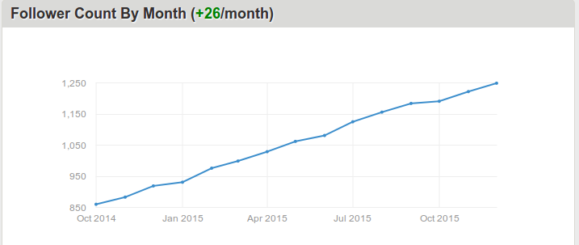

Figure 1 - @linuxaustralia Twitter account followers by month

Web presence

Linux Australia's web presence remains a key digital property, averaging around 4500 page views per calendar month, with peaks and troughs in line with the key activity periods of the organisation such as voting, calls for linux.conf.au bid cities etc.

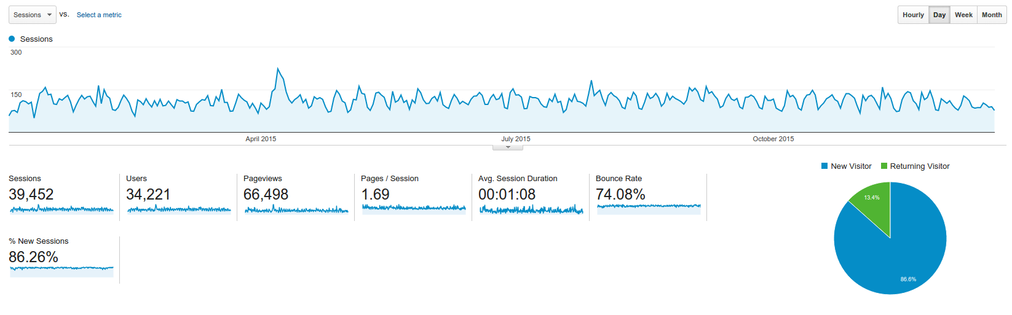
Figure 2 – page views to linux.org.au over 2015 from Google Analytics

The most popular content on the site remains the introductory information around free and open source software, jobs information and information about linux.conf.au. Jobs information is a key section of the linux.org.au site and is one that future Councils may wish to focus on for additional attention or promotion.

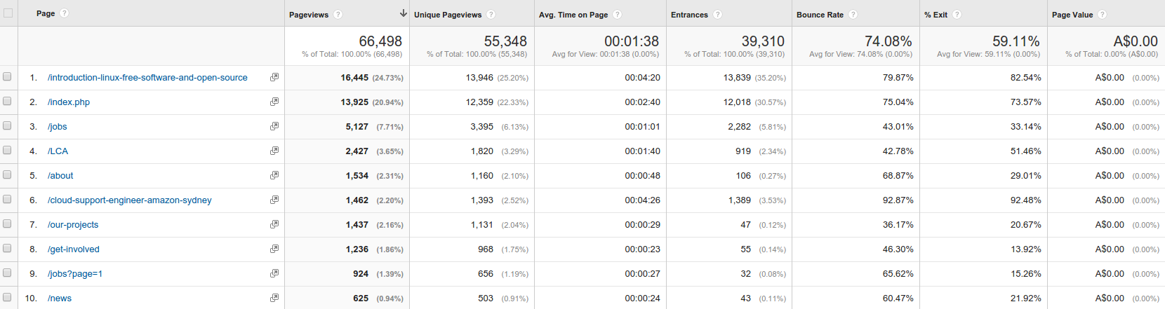
Figure 3 – key statistics on most popular content on linux.org.au
The site itself is somewhat out of date; future Councils may wish to consider an upgrade to a more recent version of Drupal, possibly in line with a MemberDB replacement.

Kathy Reid
Media Team
Linux Australia
December 2015

media@lists.linux.org.au

